Model Optimization and Tuning Phase Template

Date | 12 April 2026
Name | Nikita Tanaji Mane
Project Title | Restaurant Recommendation system
Maximum Marks | 10 Marks

Model Optimization and Tuning Phase

The Model Optimization and Tuning Phase involves improving our machine learning recommendation model to get the best performance. This includes adjusting the model's parameters, experimenting with different algorithms, and selecting the most suitable model based on evaluation metrics such as accuracy, precision, recall, and RMSE (Root Mean Squared Error).

Our restaurant recommendation system was designed to suggest similar restaurants based on location, user ratings, cuisines, and cost using collaborative filtering and content-based filtering techniques.

Hyperparameter Tuning Documentation (8 Marks):

Model | Tuned Hyperparameters
Model 1: Content-Based Filtering | - Similarity Metric: Cosine similarity was used as the primary metric to compute similarity between restaurants based on features like cuisines, rating, and cost.  - Top N Recommendations: The number of top similar restaurants returned was tested with values like 5, 10, and 15.

 | 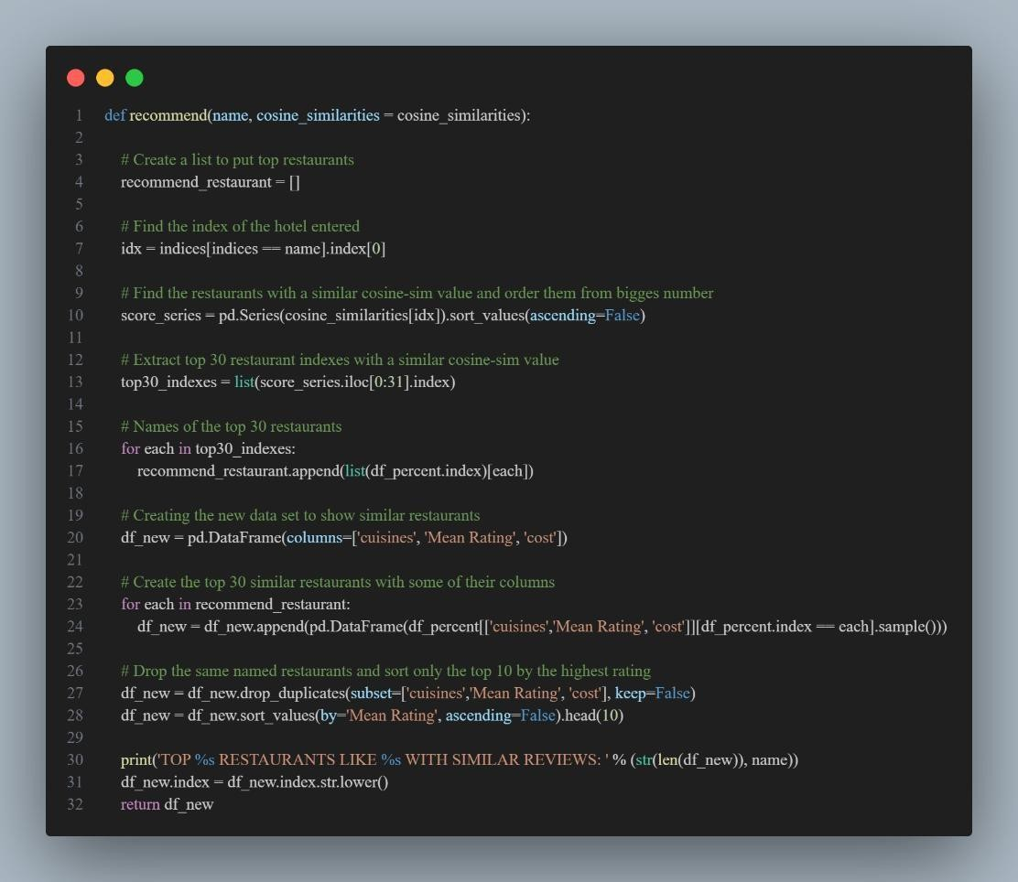
Model 2: Collaborative Filtering | - Algorithm: SVD (Singular Value Decomposition) from the Surprise library.  - Learning Rate: Tuned values such as 0.005, 0.01, and 0.02 were tested.  - Regularization: Parameters such as 0.02, 0.05 were tried to avoid overfitting.  - Number of Epochs: Adjusted between 20 and 100 epochs.  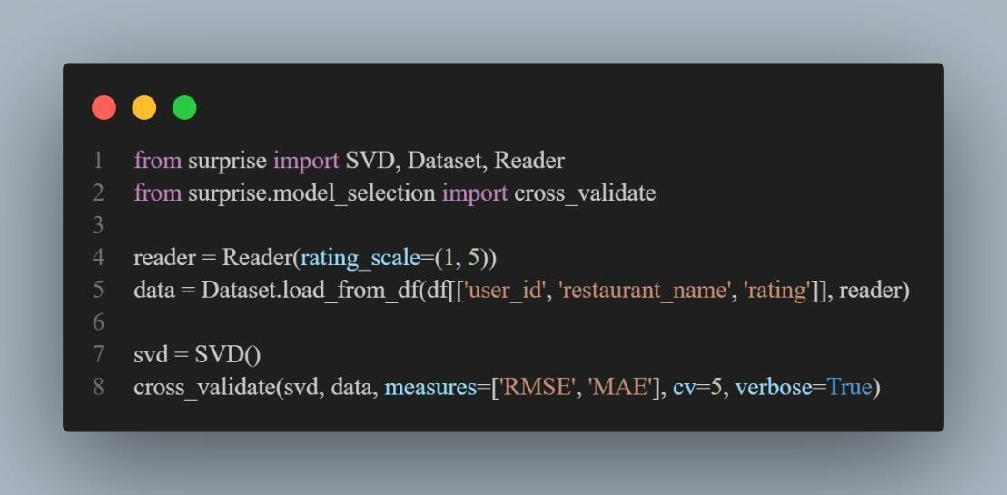

Final Model Selection Justification (2 Marks):

Final Model | Reasoning
Model 1: Content-Based Filtering | Selected due to its simplicity and good performance without requiring detailed user history. It gave interpretable and relevant results using restaurant features like cuisines, ratings, and cost.

